Appendix D – Sittings calendar

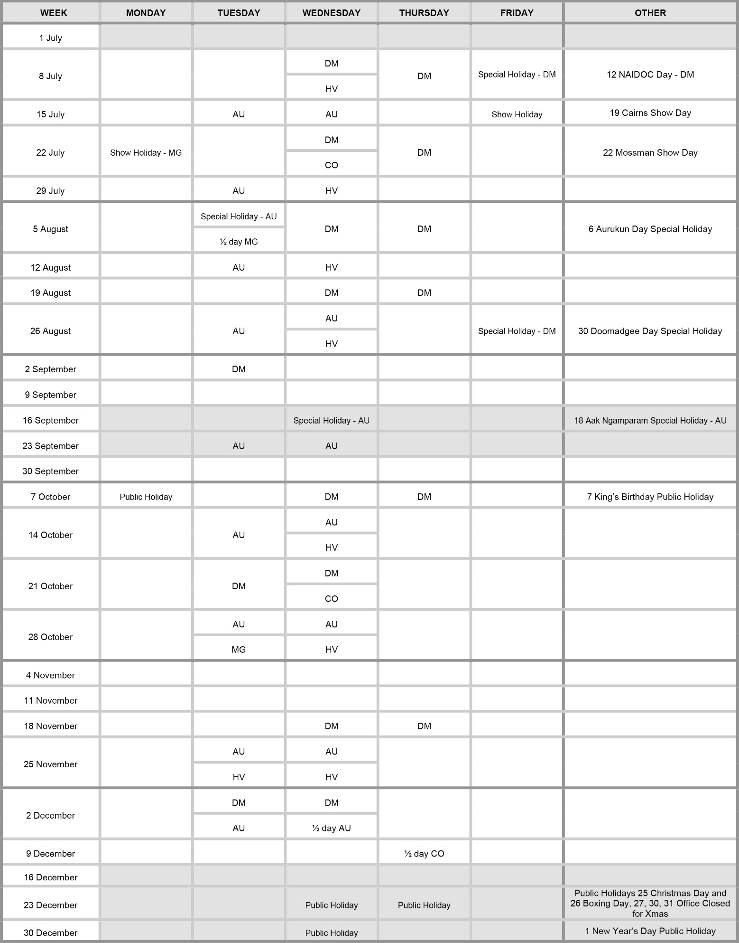
Family Responsibilities Commission 1 July 2024 to 31 December 2024

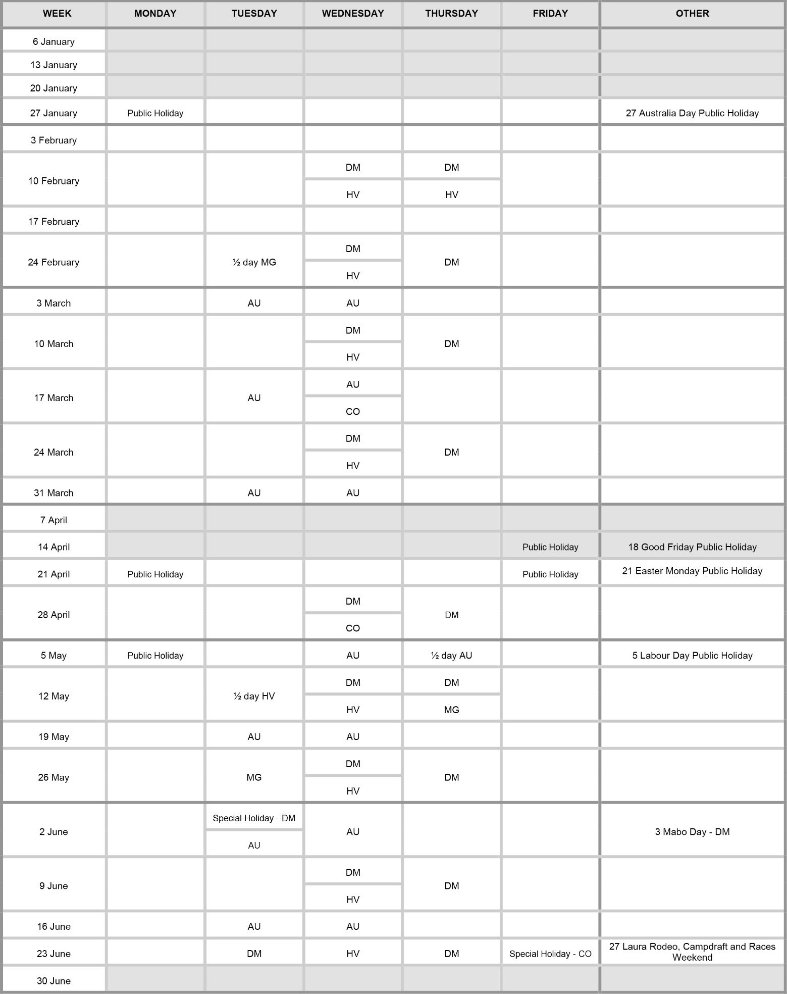
Family Responsibilities Commission 1 January 2025 to 30 June 2025

